**Institute of Computer Technology**

**B. Tech. Computer Science and Engineering**

**Semester: III**

**Sub: Database Management System**

**Course Code: 2CSE301**

**Practical Number:5**

**Objective:**

*Perform Queries using Group by and Having clause.*

**Queries:**

1. **How many employees are there in each department?**

**Code :**

Select department_id,COUNT(name) from employees GROUP BY department_id;

**Output :**

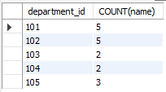

1. **Find out total number of job role assigned in each department.**

**Code :**

Select department_id,COUNT(job_role) from employees GROUP BY department_id;

**Output :**

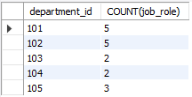

1. **Find out employee’s names and salary whose having salary more than 2000. (Duplication in employee name should be removed)**

**Code :**

Select DISTINCT name,salary from employees where salary>2000;

**Output :**

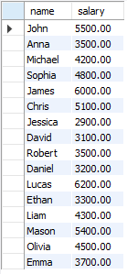

1. **Find out number of employees hired after 03rd April 1991.**

**Code :**

Select name from employees where hire_date>'1991-04-03';

**Output :**

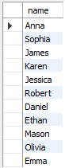

1. **lists the number of employees in each job role, sorted high to low.**

**Code :**

Select job_role,COUNT(employee_id)as employee_count from employees GROUP BY job_role ORDER BY employee_count DESC;

**Output :**

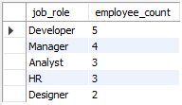

1. **lists the number of employees in each department. Only include department with more than 3 employees in each.**

**Code :**

Select department_id,COUNT(name) as name_count from employees GROUP BY department_id HAVING name_count>3;

**Output :**



1. **Display the total amount of the salary on each department.**

**Code :**

Select department_id,SUM(salary) from employees GROUP BY department_id;

**Output :**

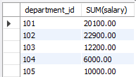

1. **Count total number of employees assigned in each department whose name end with “n”.**

**Code :**

Select department_id,COUNT(employee_id) from employees where name like '%n' GROUP BY department_id;

**Output :**



1. **Find out total number of employees having "a" as a character in their name in each department.**

**Code :**

Select department_id,COUNT(employee_id) from employees where name like '%a%' GROUP BY department_id;

**Output :**

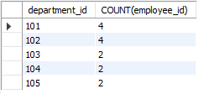

1. **Find out total number of employees having salary more than average salary of all the employee in each department.**

**Code :**

Select department_id,COUNT(*) AS num_employees_above_avg from employees e WHERE salary>(SELECT AVG(salary) FROM employees Where department_id = e.department_id) GROUP BY department_id;

**Output :**

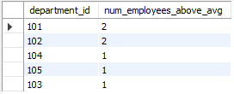

1. **Display total number of employees in each department whose department having more than 2 employees also display department id in descending order.**

**Code :**

Select department_id,COUNT(employee_id) as employee_count from employees GROUP BY department_id HAVING employee_count>2 ORDER BY department_id DESC;

**Output :**

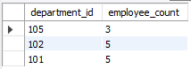

1. **Display department wise average salary of employee.**

**Code :**

Select department_id,AVG(salary) as salary_avg from employees GROUP BY department_id;

**Output :**

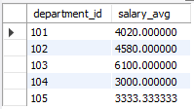

1. **Display department id of the employee along with salary whose salary is maximum in respective department..**

**Code :**

Select department_id,MAX(salary) as max_sal from employees GROUP BY department_id HAVING max_sal ;

**Output :**

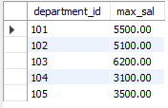

1. **Display department id of the employee along with salary whose salary is minimum in respective department.**

**Code :**

Select department_id,MIN(salary) as min_sal from employees GROUP BY department_id HAVING min_sal ;

**Output :**

